What I have done on the model

The poultry fecal images were taken in Arusha and Kilimanjaro regions in Tanzania between September 2020 and February 2021 using Open Data Kit (ODK) app on mobile phones. The typical normal fecal material which is the ‘healthy’ class and Coccidiosis disease, the ‘cocci’ class were taken from poultry farms.
For my model I make 3 class 1. Newcastle 2. Normal 3. Other abnormal
For the pre processing technique resize the image to 224X24.
- MobileNetv2
Parameter used for this training epochs=50,
batch size = 8
patience = 3, min_lr = 1e-8, histogram_freq = 1
Result :-
Train acc= 99.98, val acc = 98.1, Test acc = 98.56, val loss = 0.083.

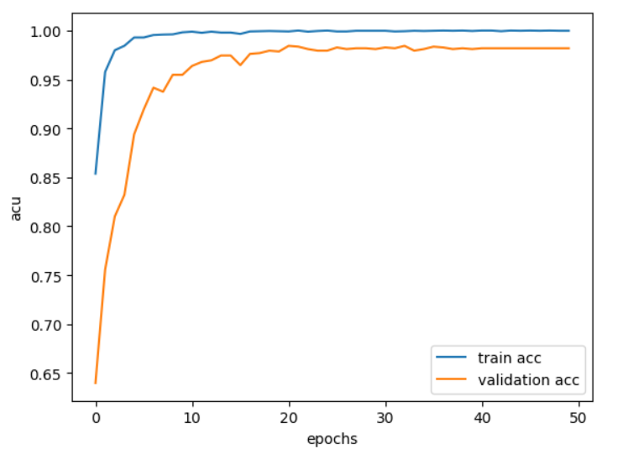
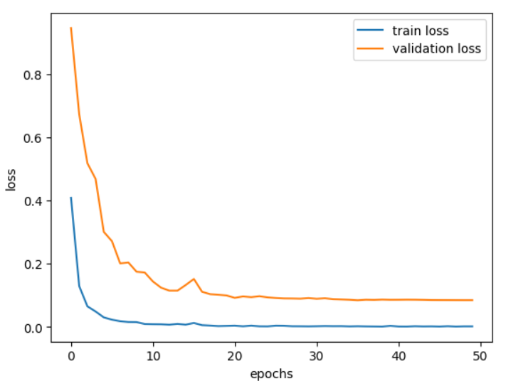

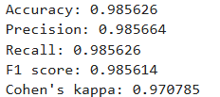

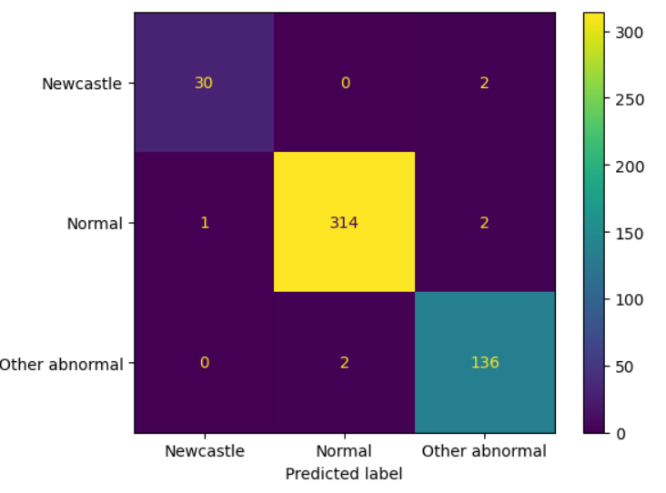

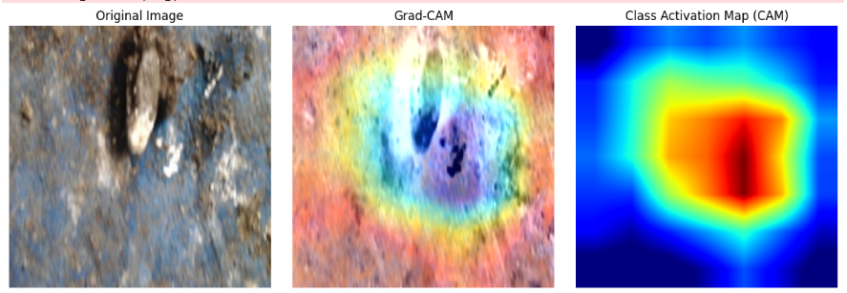

- Model :- ResNet50
3 class : Newcastle, Other abnormal, Normal
Image_size = (224,224)
Parameter used :- patience = 3, min_lr = 1e-8, batch_size = 8,
Epochs = 50.
Result:-Train acc = 100%, Val acc = 98.6, Test acc= 99.38.

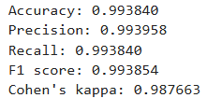
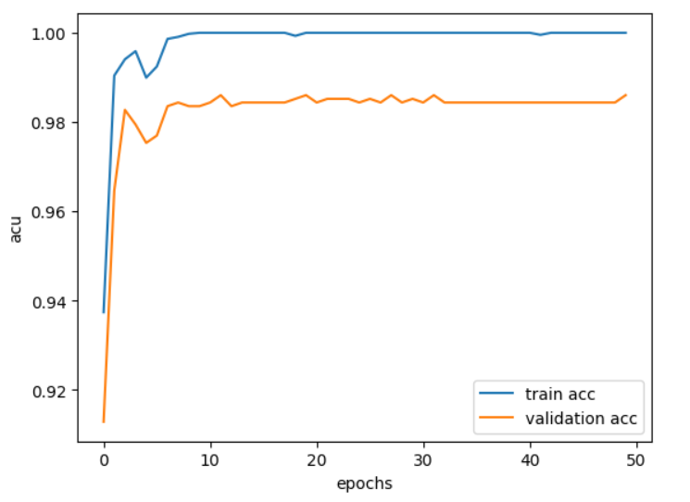

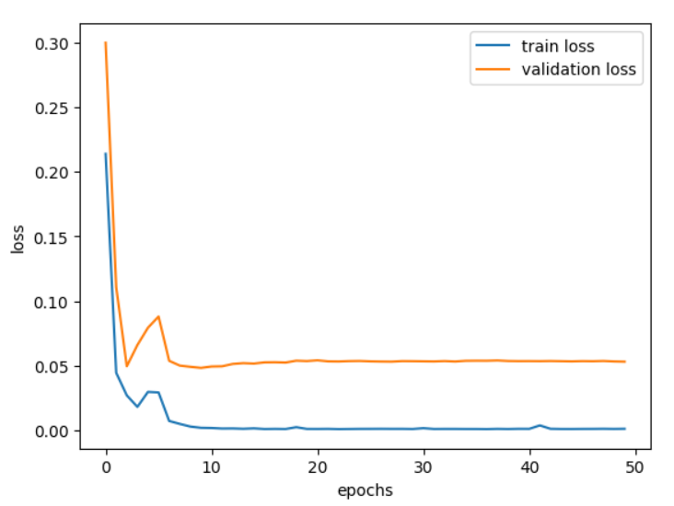

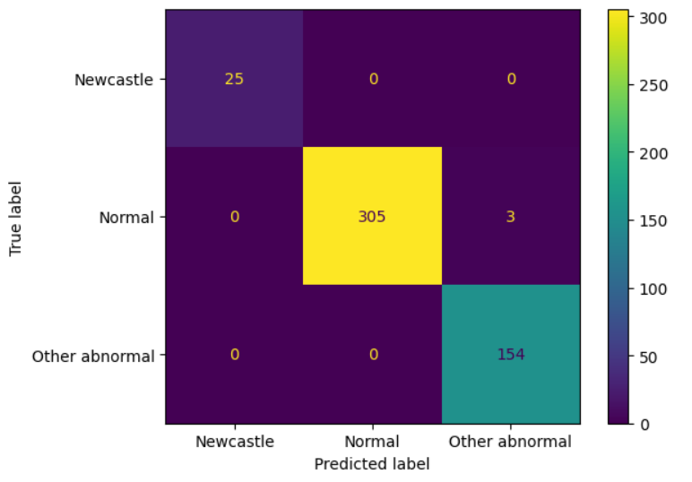

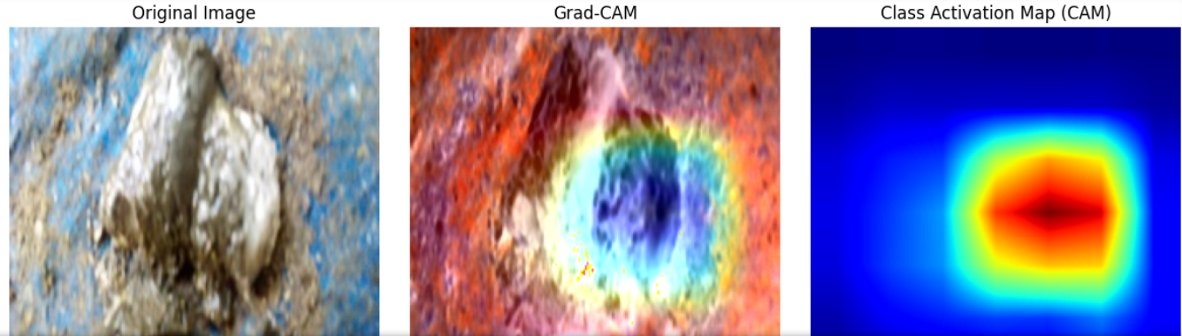
- Model :- EfficientNetB0
3 class
Pre processing technique used resize
Parameter used :- patience = 3, min_lr = 1e-8, batch_size = 8, epochs = 70.
Total params: 3,634,534 (13.86 MB)
Trainable params: 3,595,711 (13.72 MB)
Non-trainable params: 38,823 (151.66 KB).
Result:- Train acc = 99.95, Val acc = 98.36, Test acc = 99.35,
Train loss = 0.0026, Val loss = 0.06
